Paper Title

Peter Author1
University XY, Department of Z, 12345 Oxbridge, E-mail: name@university.org.uk
Suzie Author2
XY GmbH, 12345 Industry town, E-mail name@firma.co.uk
Abstract
Write an abstract of max. 150 words summarising your paper.
Keywords
Provide 4 to 6 keywords.

General Information
Authors are requested to submit either an extended abstract or a full paper. The total length of the extended abstract should not exceed three pages (incl. references) and the total length of the paper should not exceed 7,500 words (incl. references). Please submit your contribution as a Word document based on this template. You must format your paper as shown below. All formulas, tables, and images must be embedded in the paper where they should later appear in print.

Working with the template
The template is used to facilitate the formatting of your paper to ensure consistent, professional presentation of all conference papers in the “Conference Reader”. It contains all of the necessary settings for your paper (headings, text blocks, lists, etc.).
Open the template and save it with your new title. You can then enter your text directly into the template. The essential components of your contribution are the title, information about the author(s), the abstract (max. 150 words), the body, and the bibliography.
Please make sure that each section matches the style provided. For the current section, for example, the style "Text" should be selected to be (cf. Fig. 1). The styles have been numbered in the order of their probable occurrence in the text.

Fig. 1: Selecting a style
The name(s) of the author(s) appear on the header of every even page. Please replace "Peter Author" with your name(s) (double click "Peter Author" on an even page). Tables, pictures, diagrams, photos, drawings, and other images are to be integrated into the text and numbered in the order in which they are addressed in the text. Use the Captioning style to label your tables and images.
(1)
Equations are numbered as shown. They need to be referenced in the text as Equation (1) or Equations (1) and (2) (choose Equation style).

Pasting from other documents and programs
If you have created your text in another word processing programme, please copy it to MS Word and reformat it using the format styles of the template. When pasting, please right-click and select the "Keep Text Only" option (Fig. 2). You can then adapt your text to the required style. Please use the built-in styles; never format directly within the text.
Fig. 2: Pasting text from another document

Sample chapter (Heading 1)
This sample chapter illustrates the use of the style.

Sample subheading (Heading 2)
A subsection begins here.

Sample subsection 1 (Heading 3)
This is a text. This is a text. This is a text. This is a text. This is a text. This is a text. This is a text. This is a text. This is a text. This is a text. This is a text. This is a text. This is a text. This is a text. This is a text.
- Sample list:
- Sample list:
- Sample list:
This is a text. This is a text. This is a text. This is a text. This is a text. This is a text. This is a text. This is a text. This is a text. This is a text. This is a text. This is a text. This is a text. This is a text. This is a text.

Sample subsection 2 (heading 3)
Fig. 3 shows a sample image.
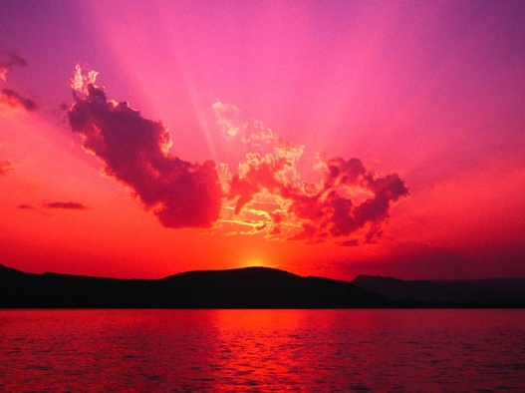
- Figure format 1200 dpi for line art, 600 dpi for grayscale and 300 dpi for colour.
- Figures must be saved separate to text in TIFF (tagged image file format). Please do not embed figures in the manuscript file.
- All figures must be numbered in the order in which they appear in the manuscript (e.g. Figure 1, Figure 2). In multipart figures, each part should be labelled (e.g. Figure 1(a), Figure 1(b)).
- Figure captions must be saved separately, as part of the file containing the complete text of the manuscript, and numbered correspondingly.
Fig. 3: Representation of XYZ (following Doe, 2016)

Sample subsection 2 (heading 3)
The file ICTB2022_Paper_Template.dot file contains all the relevant styles. The following lists every style:
- 01 Title
- 02 Author Name
- 03 Author Data
- 04 Abstract
- 05 Keywords
- 06 Body
- Heading 1,06 Heading 1
- Heading 2,07 Heading 2
- Heading 3,08 Heading 3
- 09 Captions
- 10 Equation
- 11 Graphics
- 12 List
- 13 Acknowledgement
- 14 References
- 15 Appendices (as appropriate)
- 16 Table (s) with captions (s) on (individual pages), figure caption (s)

Sample subchapter (Heading 2)
A subsection begins.

Literature
Citations should follow the standards of the American Psychological Association (APA), as shown below:
- This is a text (Seuring & Müller, 2004, p. XY).
- This is a text according to Holton (2004, p XY).
Please list your sources in the references in alphabetical order. The references should be grouped as follows:

Books
Emerich, M. (2011). The gospel of sustainability: Media and market and lohas. Chicago: University of Illinois Press.
Papers within edited collections
Jones, D. G., Shaw, E. H., & McLean, P. A. (2010). The modern schools of marketing thought. In P. Maclaran, M. Saren, B. Stern & M. Tadajewski (Eds.), The sage handbook of marketing theory (pp. 42-58). London: Sage.
Journal articles
Leonidou, L. C., Coudounaris, D. N., Kvasova, O., & Christodoulides, P. (2015). Drivers and outcomes of green tourist attitudes and behavior: Sociodemographic moderating effects. Psychology & Marketing, 32(6), 635-650.
Unpublished conference presentations
Brynjarsdottir, H., Håkansson, M., Pierce, J., Baumer, E., DiSalvo, C., & Sengers, P. (2012). Sustainably unpersuaded: How persuasion narrows our vision of sustainability. Paper presented at the Proceedings of the SIGCHI Conference on Human Factors in Computing Systems.
Unpublished papers
Nandhakumar, J (1993): The practice of executive information systems development: an in-depth case study. PhD Thesis, Department of Engineering, University of Cambridge.
Online paper
BSR. (2015). Transparency, purpose, and the empowered consumer: A new paradigm for advertising. Retrieved from http://www.bsr.org/en/our-insights/report-view/responsibility-and-transparency-in-advertising. (accessed online: 25.04.2016).

